Glass Bottle

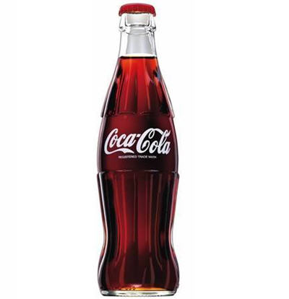

- Where does it go after it is used?

- Can it be reused? If so, in what way?
Plastic Bottle

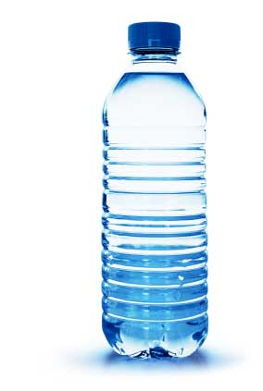

- Where does it go after it is used?

- Can it be reused? If so, in what way?
Newspaper

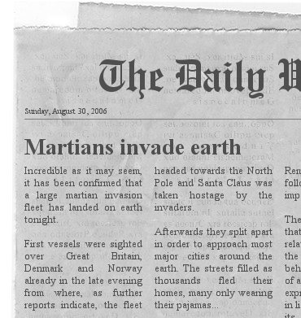

- Where does it go after it is used?

- Can it be reused? If so, in what way?
Coffee Grounds

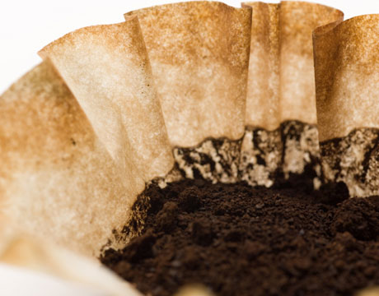

- Where does it go after it is used?

- Can it be reused? If so, in what way?

Cardboard box
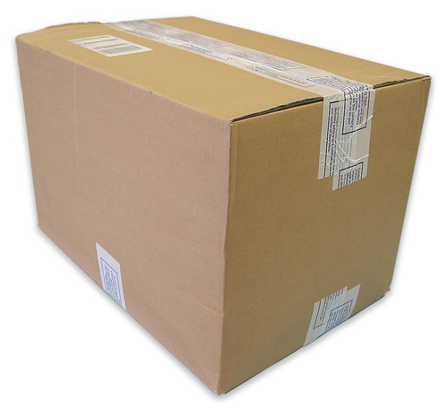

- Where does it go after it is used?

- Can it be reused? If so, in what way?
Aluminum cans

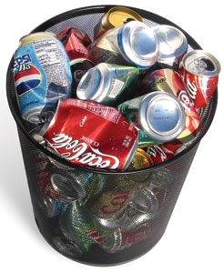

- Where does it go after it is used?

- Can it be reused? If so, in what way?
Rechargeable batteries

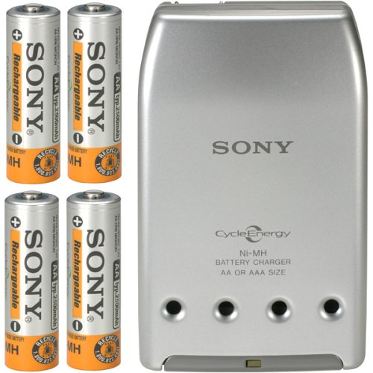

- Where does it go after it is used?

- Can it be reused? If so, in what way?
Plastic grocery bags

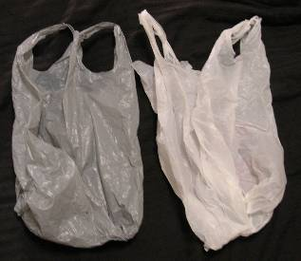

- Where does it go after it is used?
- Can it be reused? If so, in what way?

- Did you know that 2 million plastic bottles are used every 5 minutes in the United States? Review the following data and complete the table using the pattern shown.
Number of Plastic Bottles Used Every 5 Minutes in the United States
Time (in minutes) | 5 | 10 | 15 | 20 | 25 | 30 | 35 | 40 | 45 | 50 | 55 | 60
Bottles (in millions) | 2 | 4 | 6 | 8

- What pattern do you see in the above table?
__________________________________________________________________________________________________
- What is another way to describe the pattern above?
__________________________________________________________________________________________________
- How many plastic bottles are used in one day?

__________________________________________________________________________________________________
__________________________________________________________________________________________________
__________________________________________________________________________________________________
__________________________________________________________________________________________________
__________________________________________________________________________________________________
- If only 1/3 of plastic bottles are recycled daily in the United States, how many bottles are NOT recycled?

__________________________________________________________________________________________________
__________________________________________________________________________________________________
__________________________________________________________________________________________________
__________________________________________________________________________________________________
__________________________________________________________________________________________________
__________________________________________________________________________________________________

- About 453 empty plastic water bottles equals roughly 1 pound of waste. Use your answer to #5 to estimate how many pounds of waste are created every day JUST from plastic bottles (from bottles that are NOT recycled).

__________________________________________________________________________________________________
__________________________________________________________________________________________________
__________________________________________________________________________________________________
__________________________________________________________________________________________________
__________________________________________________________________________________________________

- What might be 2 potential consequences, positive or negative, of NOT recycling plastic bottles?

__________________________________________________________________________________________________
__________________________________________________________________________________________________
__________________________________________________________________________________________________
__________________________________________________________________________________________________
__________________________________________________________________________________________________
__________________________________________________________________________________________________
__________________________________________________________________________________________________

- Brainstorm some ways to increase the amount of recycling of plastic bottles (or decreasing the amount of plastic bottles that are thrown away) with your table mates and record your ideas below:
__________________________________________________________________________________________________
__________________________________________________________________________________________________
__________________________________________________________________________________________________
__________________________________________________________________________________________________
__________________________________________________________________________________________________
__________________________________________________________________________________________________

County ready to begin buying property for landfill expansion
Posted: Tuesday, March 19, 2013 2:00 am By LYNNETTE HINTZE/The Daily Inter Lake |
The Flathead County commissioners on Monday voted unanimously to proceed with buying properties adjacent to the landfill for future expansion of the county’s solid waste operation.
It was a procedural vote that sets in motion the process to begin the acquisitions but doesn’t define whether a group of 14 parcels covering 91 acres or a much larger 523-acre tract is the preferred option.
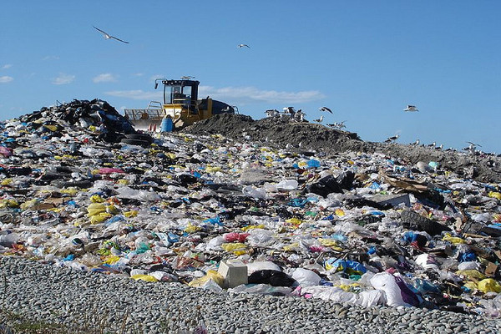
“Everything’s on the table yet,” Commissioner Pam Holmquist said after the vote. “I’m leaning toward the 14 parcels, but this doesn’t lock us into the 14.”
The county Solid Waste Board has been studying both the 14 parcels next to the landfill’s southwest corner — owned by 14 different families — and a second 523-acre site west of Prairie View Road owned by Hank and Lacy Galpin of Sky-Air Enterprises.
The Galpins’ property is appraised at around $3.3 million and was the preferred alternative in a 2009 strategic plan for the landfill.
The 14-parcel tract also is appraised at about $3.3 million.
The board has said it wants to have enough land to bury garbage for 100 years. Current capacity at the landfill is about 50 years.
Prunty noted that a third option always had been not proceeding with either of the two land alternatives.
Hank and Lacy Galpin voiced their concerns about the process during the commissioners’ public comment segment on Monday.
A letter submitted by Hank Galpin stated he believes their property is the best choice for the county because it’s five times the size of the 14-parcel option for about the same cost. It’s geologically suitable, near the current landfill and would meet the property needs of the landfill for a century, he added.
Galpin also asked Commissioner Gary Krueger to excuse himself from voting on the property acquisition because Krueger owns property across the river from the Galpins’ property.
Krueger said he already can see “the dump” from his house, but that it doesn’t bother him.
“I’m going to make my decision on what’s very best for Flathead County,” Krueger said. “I’ll look mostly at dollars and cents.”
It would cost the county about $1.6 million more to expand to the Galpins’ property than add the 14 parcels closer to the landfill. Krueger said the county will conduct a thorough assessment of projecting what it will cost to operate a larger landfill. An all-weather road would need to be built to the expansion site and a new gas-containment facility likely would be needed, he pointed out.

Company Turns Landfill Waste into Eco-Friendly 'Plastic Lumber'
by Patricia Escarcega 03/18/13
What if you could build an entire house out of the waste and debris found in landfills?
Envirolastech, a Rochester, Minn. firm specializing in the development of sustainable building products, hopes to do just that with its production of a new "plastic lumber."
The company has developed a proprietary formula that uses different mixtures of mineral ash, recycled resins and solid waste materials to create what it calls a "true replacement for wood."
“Ash is the number one by-product that goes into our landfills, whether it’s coal or incinerator ash. It makes up between 40 to 60 percent of every landfill we have,” said Paul Schmitt, president of Envirolastech, in an interview with local Minnesota news station.
The company says its products are made from 100 percent recycled inorganic materials taken directly from landfills and curbside pickups. All products are also recyclable.
“We’ve produced and developed over 30 products already,” Schmitt told CBS 4 Minnesota. “We can build a complete house out of garbage.”
The plastic lumber is embossed with wood grains to give the appearance of real wood, but it is stronger than conventional wood, the company says. It cannot absorb moisture, so it won't promote mildew or mold. Products can be painted and stained like wood, as well as cut, screwed, nailed and milled with standard carpentry and woodworking tools.
The company says that the plastic lumber is in its tenth year of field testing and so far shows no signs of chipping, peeling or color fade.

Number of Plastic Bottles Used Every 5 Minutes in the United States
Time (in minutes) | 5 | 10 | 15 | 20 | 25 | 30 | 35 | 40 | 45 | 50 | 55 | 60
Bottles (in millions) | 2 | 4 | 6 | 8 | 10 | 12 | 14 | 16 | 18 | 20 | 22 | 24

- Create an equation from the table above to represent the number of bottles recycled for any number of hours. Use x to represent the number of hours (not minutes) and y to represent the number of bottles (in millions).

- Use this equation to predict how many millions of bottles are used in one week by the United States.

- Use this equation to predict how long it will take the United States to accumulate 1 trillion (1,000,000,000,000) bottles.

- What is the slope of your equation? What does it mean in the context of this problem?

- Now look at the amount of waste generated per person in a single day in the United States. Organize the data in the table below on a line graph. (Label each axis and title your graph)
Year | 1960 | 1970 | 1980 | 1990 | 2000
Pounds per Person per Day | 2.7 | 3.3 | 3.7 | 4.5 | 4.6

- Using your graph, predict the number of pounds per day the average person will discard by 2020. Explain how you came up with your selection.

- Create an equation for the table of values above.

- Substitute the year 2020 into your equation and compare the result to your answer in #6. Were they the same? Were they different? Why?

